**The Invisible String- Activity Ideas!**

The Invisible String is a heart-warming story about how we are all connected to the people we love, no matter how far apart we may be.

1.Craft Experience- Using pipe cleaners and beads create two hearts, each representing either side of the string.

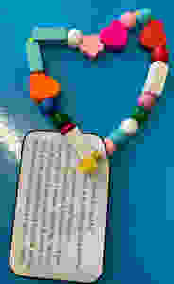

2. Another great activity is a work sheet where the children draw themselves and who they feel most connected to by an invisible string. The activity is designed to help them think of all the connections they have with their friends and family. Take this opportunity to show them they are loved by many people in their lives and help them feel grateful for these connections. Just remember, it doesn’t matter how far away they may be, the string can reach anywhere and everywhere.

